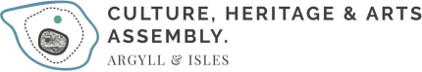

4th September 2024
To whom it may concern

On behalf of the CHARTS Board and Steering Group, representing individual artists and leading arts organisations across Argyll and Bute, we note with concern the decision to close the Open Fund to individuals. We understand the issue that funds have not been released from the Scottish Government.

We all know the impact this will have on the sector but want to stress the disproportionate affect this will have on less established artists - especially those in rural Scotland - and In addition the communities they serve who are not able to access the broader cultural offer in urban centres and the central belt.

Our organisation supporting Argyll’s culture sector is particularly impacted, through our role to nurture innovation and individual career development.

What can we do to help mobilise and support the creative sector to elicit a more positive response from the Scottish Government?

We look forward to hearing from you

Yours Sincerely

Jo McLean
Chair, CHARTS Board
https://www.chartsargyllandisles.org

