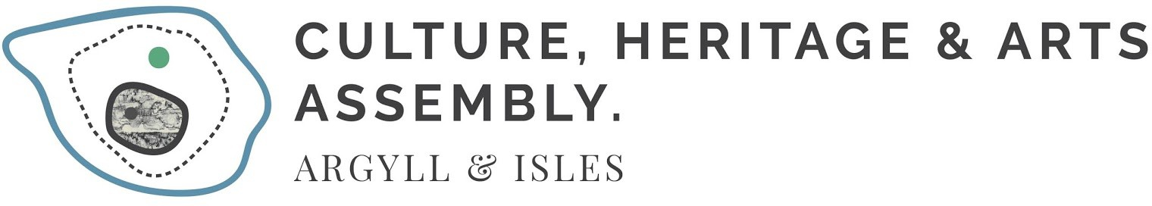

GUIDANCE & Application Form

COLMCILLE 1500 film competition – december 2021

About the Colmcille 1500 Community Film Competition

The CHARTS Illuminations event series will be held at five locations throughout Argyll and Bute on December 7th, 2021 and is designed to celebrate and commemorate the life and legacy of Colmcille as part of the national Duais Dìleab Chaluim Chille / The Colmcille Legacy Award Programme. This programme as part of the Year of Colmcille, 1500 has offered awards to Gaelic artists and Gaelic partnerships and has been run by CHARTS since 2020 in close collaboration with Bòrd na Gàidhlig and Argyll and Bute Council.

The Colmcille 1500 film competition taking place on the anniversary of the birth of Colmcille is designed as a special part of the Colmcille Legacy Award programme to engage Gaelic communities, speakers and learners and celebrate achievements by artists during the themed Year of Colmcille, 1500 (2020-2021).

This film competition invites video films from Gaelic speakers or learners to capture events in their local areas and may include any Colmcille sites close to you or a Gaelic song, poem or music linked to Colmcille or Argyll Gaelic. Community groups or individuals are welcome to apply.
About the Prize

The first prize will be £100 and the top three videos will be shared online at the Argyll Gaelic Gathering on 12 March 2022. The winners will be announced on December 15th 2021.

Illumination events are due to take place at Ardrishaig, Bute, Dunoon, Helensburgh and Oban and video films can be between 30 seconds and 5 minutes long.
Watch our social media for location information soon !

Easy to Apply !

Please fill out the form below and submit to info@chartsargyllandisles.org by 5pm Friday 10th December.

Winners will be selected from the films uploaded to Argyll Gaelic Forum Facebook page.
Applicants accept sole liability for any content posted to the Facebook page. You agree to indemnify CHARTS and Argyll Gaelic Forum against and costs, claims, damages, liability, legal fees, loss and other expenses we may incur resulting from your post(s). We retain the right to remove or block access to any material posted at our sole discretion.
Application Form
Community Film Competition

Name

Address
Email
Telephone number

If you are applying on behalf of a group, please name the group and the lead applicant

I confirm I am a fluent Gaelic speaker / learner (please delete as appropriate)

Location of film -

About my film (optional - no more than 100 words)

Declaration:

I confirm that I am the film maker and that I understand that by submitting this application, I am happy for CHARTS to share this information with the selection panel including Bòrd na Gàidhlig and Argyll and Bute Council. I have permission from the people included in the film and if required also from the site the film was taken.

Please sign here (electronic signature permitted)

Date

Other information
Expecting a lot of interest and many great films, the selection panel may wish to highlight various entries on websites and social media following the final decision. Please state below if you would be happy for CHARTS, Bòrd na Gàidhlig and Argyll and Bute Council to share your work with full credit.

Please delete as appropriate YES / NO

Please Note

Winners will be selected from the films uploaded to Argyll Gaelic Forum Facebook page.

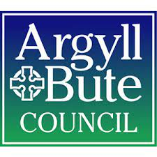 | 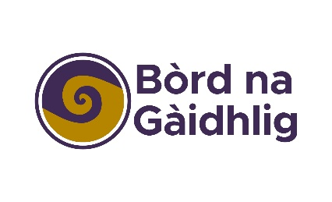 | 